Parallel Execution and Start up documentation.

How to run the project.

1. Go to Terminal and type NPM Test

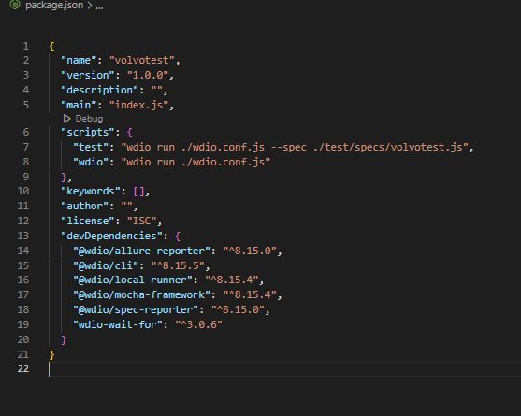It will automatically run the project because we already indicate the the package.json file in what project we will run which is the volvotest.js

In the capabilities is where we added another browser that we want to use for testing.   
In my case I added Mozila Firefox and for the maxInstances it means If how many times you want to test it in the given browser.

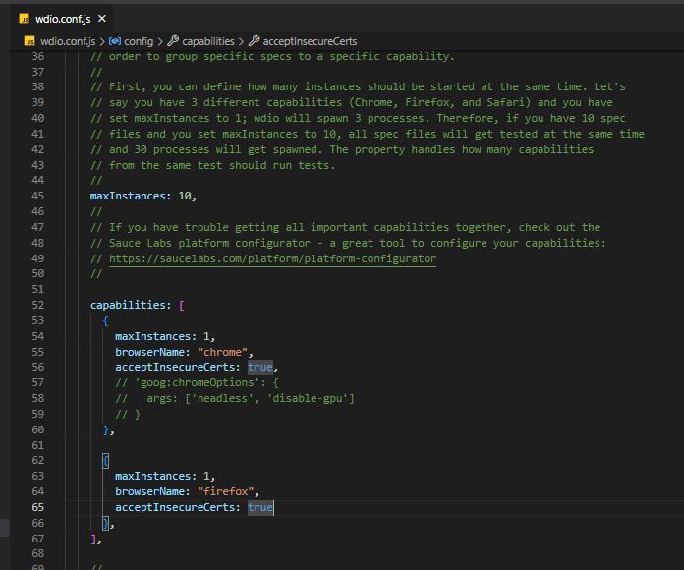

In the reports we can see the reports that we’ve download it when we are installing or creating a project which is the spec and allure reports.

In the mochaOps we add the timeout: 99999 it means you set the timer limit on testing.

